Debit cards

a debit card is a payment card that deducts money directly from a consumer's checking account to pay for a purchase.

**Features of Debit Cards**

1. **Immediate Deduction**: Funds are immediately transferred from the account holder's bank account when a purchase is made.
2. **Access to ATMs**: Debit cards can be used to withdraw cash from ATMs.
3. **Security**: Most debit cards come with security features such as EMV chips, PIN protection, and sometimes even biometric authentication.
4. **Types of Transactions**: Debit cards can be used for both point-of-sale (POS) transactions and online purchases.
5. **Overdraft Protection**: Some debit cards offer overdraft protection, allowing transactions to go through even if there are insufficient funds, typically resulting in a fee.

**Differences Between Debit and Credit Cards**

* **Source of Funds**: Debit cards use money from the user's bank account, while credit cards allow users to borrow money up to a certain limit to be paid back later.
* **Interest and Fees**: Debit cards do not charge interest as they use the user's own money. Credit cards can incur interest if the balance is not paid in full each month.
* **Credit Score**: Using a debit card does not affect your credit score, whereas responsible use of a credit card can improve it.

**Advantages of Using Debit Cards**

* **No Debt**: Since you are using your own money, you are not incurring debt.
* **Budget Control**: It is easier to manage and control spending with a debit card.
* **Convenience**: Debit cards offer a convenient way to make purchases without carrying cash.

**Disadvantages of Using Debit Cards**

* **Limited Protection**: Compared to credit cards, debit cards may offer less fraud protection.
* **Overdraft Fees**: If overdraft protection is enabled, fees can accumulate quickly.
* **No Rewards**: Debit cards typically do not offer rewards like cash back or points, which are common with credit cards.

**Popular U.S. Debit Card Providers**

* **Banks**: Major banks like JPMorgan Chase, Bank of America, Wells Fargo, and Citibank issue debit cards to their checking account holders.
* **Credit Unions**: Many credit unions offer debit cards with their checking accounts.
* **Online Banks**: Digital banks such as Ally Bank, Chime, and Varo also provide debit cards.

**Using Debit Cards Internationally**

* **Currency Conversion**: Transactions made in foreign currencies are converted to U.S. dollars, often with a conversion fee.
* **International Fees**: Some banks charge fees for international transactions and ATM withdrawals.

Latest upcoming updates

I think (with these features) we’re getting past the point where consumers may never need to manually enter an account number ever again,” said Mark Nelsen, Visa’s global head of consumer payments, in an interview.

The biggest change coming for Americans will be the ability for banks to issue one physical payment card that will be connected to multiple bank accounts.

Among the other updates unveiled by Visa are changes to tap-to-pay features. Americans will be able to tap their credit or debit cards to their smartphones to add the card to mobile wallets, instead of using a smartphone’s camera to scan in a card’s information, or tap the card to their smartphones to approve a transaction online. Visa will also start implementing biometrics to approve transactions, similar to how Apple devices use a fingerprint or face scan to approve transactions.

• **Transaction Volume**:

* In 2023, the total number of debit card transactions in the U.S. reached approximately 103 billion​ .
* The total value of these transactions was around $4.6 trillion​ .

• **Fraud Statistics**:

* Approximately 25% of debit card users reported experiencing fraud on their cards in 2020​ .
* Fraud losses for debit and general-use prepaid card transactions were 12.4 basis points in 2019, equivalent to $12.40 per $10,000 in transaction value​ .

• **Consumer Preferences**:

* About 60% of U.S. consumers preferred using debit cards for everyday purchases in 2023​
* Generation Z, which includes individuals born in 1997 and later, represents a growing segment of debit card users, often preferring digital and contactless payment methods​ .
* **Economic Impact**:
* The use of debit cards has remained resilient even during economic downturns, as consumers continue to rely on them for managing daily expenses like groceries, fuel, and bills

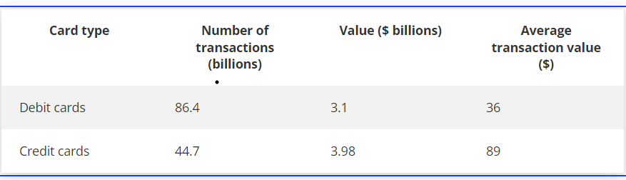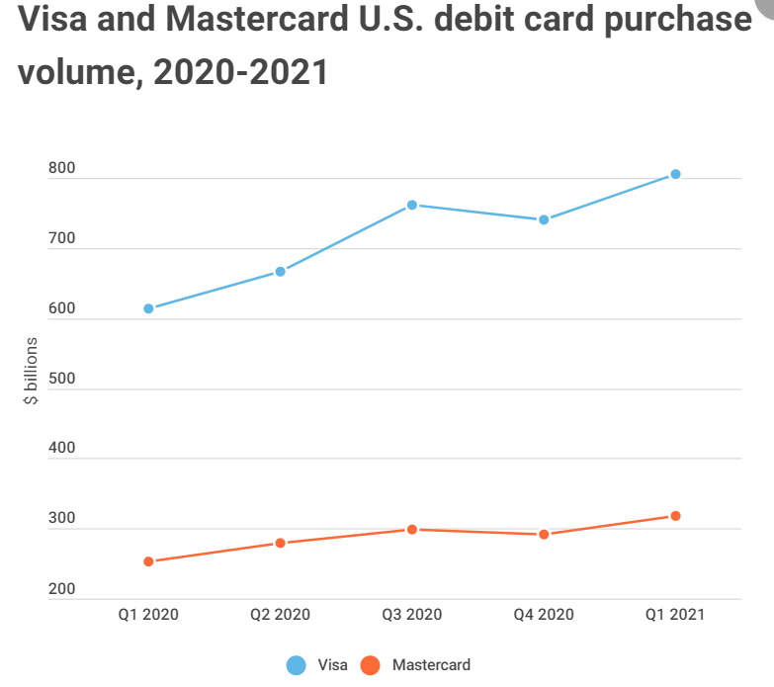

Prepaid cards

**What are Prepaid Cards?**

Prepaid cards, also known as prepaid debit cards, are payment cards that are pre-loaded with a specific amount of money. They are not linked to a bank account but can be used for purchases, similar to debit or credit cards. There are different types of prepaid cards, including general-purpose reloadable cards, gift cards, and payroll cards.

**Types of Prepaid Cards**

1. **General-Purpose Reloadable (GPR) Cards**: These cards can be reloaded with funds and used for various transactions, including online shopping and bill payments.
2. **Gift Cards**: These are preloaded with a fixed amount and typically used for specific retailers or as a general-use card.
3. **Payroll Cards**: Employers use these to pay wages to employees who do not have bank accounts.
4. **Government Benefit Cards**: Used to distribute benefits such as unemployment insurance, social security, and food assistance.

**Key Features**

* **No Credit Check**: Prepaid cards do not require a credit check, making them accessible to individuals with poor or no credit history.
* **Spending Control**: Users can only spend the amount loaded onto the card, which helps in budgeting and avoiding debt.
* **Reloadable**: Most prepaid cards can be reloaded with additional funds.
* **Wide Acceptance**: Prepaid cards are accepted at most places where debit and credit cards are used, including online and in-store purchases.

**Usage Statistics and Trends**

1. **Market Size**: In 2023, the prepaid card market in the U.S. was valued at approximately $447 billion​
2. **Growth**: The market is projected to grow at a compound annual growth rate (CAGR) of around 10% from 2023 to 2030​ .
3. **Consumer Usage**: Prepaid cards are particularly popular among unbanked and underbanked populations, which constitute about 25% of U.S. households​.

**Advantages of Prepaid Cards**

* **Accessibility**: Prepaid cards provide financial services to individuals without traditional bank accounts.
* **Budgeting Tool**: They help users manage their spending by limiting expenditures to the preloaded amount.
* **Security**: Prepaid cards offer a secure way to carry money without the risks associated with cash.
* **Gift Option**: They serve as a convenient gift alternative to cash or checks.

**Disadvantages of Prepaid Cards**

* **Fees**: Some prepaid cards come with various fees, including activation fees, monthly maintenance fees, and ATM withdrawal fees.
* **Limited Protection**: Unlike credit cards, prepaid cards may not offer the same level of fraud protection or consumer dispute resolution.
* **Reloading Limitations**: Reloading funds onto prepaid cards can sometimes be inconvenient, depending on the methods available.

**Regulatory Environment**

* **Consumer Financial Protection Bureau (CFPB)**: The CFPB has implemented regulations to ensure transparency and consumer protection in the prepaid card market. These regulations require issuers to provide clear information about fees and terms of use.
* **Federal Deposit Insurance Corporation (FDIC) Insurance**: Some prepaid cards are FDIC-insured if the funds are held in an FDIC-insured account, providing additional security for users.

**Popular Prepaid Card Providers**

* **Visa and Mastercard**: Both companies offer a range of prepaid card products, including general-purpose reloadable cards and gift cards.
* **American Express**: Provides prepaid cards such as the American Express Serve.
* **Green Dot**: A leading provider of reloadable prepaid cards and banking services for individuals and businesses.
* **Netspend**: Offers a variety of prepaid card options, including payroll cards and general-purpose reloadable cards.

1. **Market Size and Growth**:
   * The U.S. prepaid card market is expected to grow significantly, reaching $1,645.77 billion by 2027, up from $658.65 billion in 2022​ .
   * Between 2019 and 2023, the market saw a compound annual growth rate (CAGR) of 7.7%, and it is projected to grow at a CAGR of 10.5% from 2024 to 2028​ .
2. **Transaction Volume**:
   * In 2021, prepaid card payments reached $610 billion, marking a growth rate of 20.6% per year since 2018​.
   * The number of prepaid card payments increased by 9.6% per year from 2018 to 2021, reaching 18.1 billion payments in 2021​.
3. **Consumer Preferences**:
   * The adoption of prepaid cards and digital wallets is higher among younger consumers, with 78% of Gen Z and 75% of millennials using digital wallets, which often include prepaid card functionalities​ .
   * Prepaid cards are particularly popular for online security and convenience, as they allow users to shop without linking to checking accounts and avoid overdraft fees​ .